Module one Discussion 2 on Indian Assimilation

Overview
The purpose of this discussion is to help you imagine how it felt to be an Indian forced to undergo assimilation at a boarding school far from home and try to understand also the point of view of other people at the time.

Instructions
For this discussion, review your readings for Unit 2. Afterwards, you will analyze the photo of Tom Torlino embedded here. You might also look at Tom Torlino's school record at the Carlisle Indian School site. Feel free to do research outside the course if you'd like other points of view.
Then form groups that represent: a Navajo student, a white male Christian missionary, or an African American who has his or her own issues with assimilation. Each group will answer the following question: How would your character describe the impact of the transformation on Tom Torlino and others like him who attended the Carlisle Boarding School? How did this experience echo the expectations of other Americans for this type of school?
To form groups, students with last names beginning with A-H will take the role of a Navajo child sent to a boarding school. Students with names beginning with I-P will take the role of a white male Christian missionary. Everyone else will take the role of an African American. Be sure to put yourself in the shoes of the person you are speaking for -- try to imagine how that person felt, what their ideals were, what they thought was good or right or appropriate at the time, even if you personally do not feel that way. Remember, history is not about you; it is about what people knew and felt and believed in the past, based on different knowledge than you and other modern people have about what happened later.
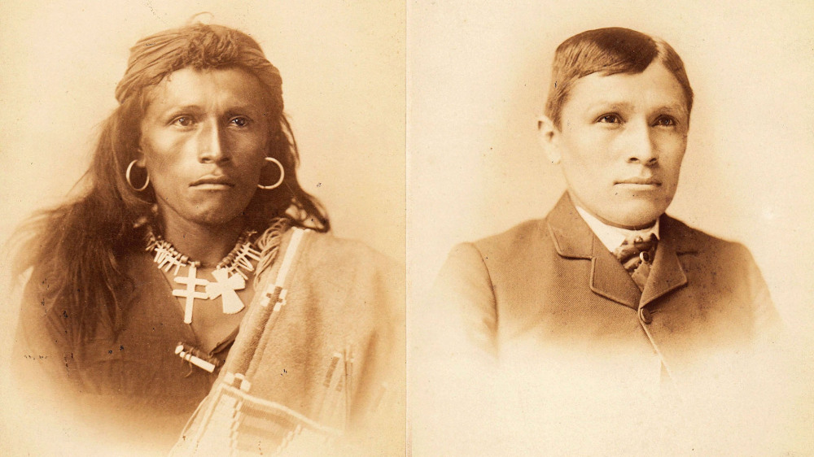
Tom Torlino, a member of the Navajo Nation, entered the Carlisle Indian School, a Native American boarding school founded by the United States government in 1879, on October 21, 1882 and just before he departed on August 28, 1886. Torlino’s student file contained photographs from 1882 and 1885. Carlisle Indian School Digital Resource Center.
Before you complete your discussion, make sure you refer to the course rubric for the expectations for this assignment. Participating in the course discussions is an important part of your final grade. In your discussions, you cannot simply reply to someone's posting with "ditto" or "I agree with you". You must answer the question(s) asked in a minimum of two paragraphs and maximum of three paragraphs. Your responses should also quote and cite the material you have read in the class so far; you may also do outside research. Use the Purdue OWL Chicago Style guide for help with the correct citation style for your quotes.
Then, respond to at least TWO classmates’ postings referring to at least one element of critical thinking. Your response to your classmates should be a minimum of two sentences, and a maximum of four sentences (refer to your Introduction to Critical Thinking and to the How to Read History Sources modules for a review of how to read primary sources).

