Overview
The purpose of this discussion is to analyze and evaluate World War II recruitment posters.

Instructions
For this discussion, review your readings for Unit 10 (pdf American Yawp: World War II Chapter 24) and study the images carefully. Feel free to do research outside the course if you'd like other points of view.
Choose ONE of the images. Prepare a discussion where you explain, based on your readings, the answers to each of the following questions:
- Who is the audience, the target market, for the image?
- What ethical or moral values does the poster use to communicate its message? Are there relevant values that are not considered in the message?
- What is the poster's purpose? What is the message that this poster communicates?
- Why is it important for this message to be delivered to this audience at this moment in time?
- How does the document communicate its message? Think about its use of language, color, space, and symbols.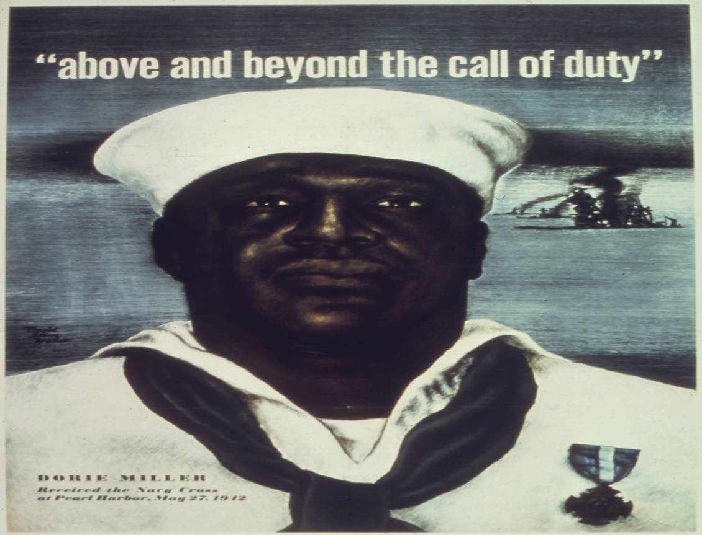
Above and Beyond the Call of Duty--Dorie Miller received the Navy Cross at Pearl Harbor, May 27, 1942, [Public Domain via Wikimedia]

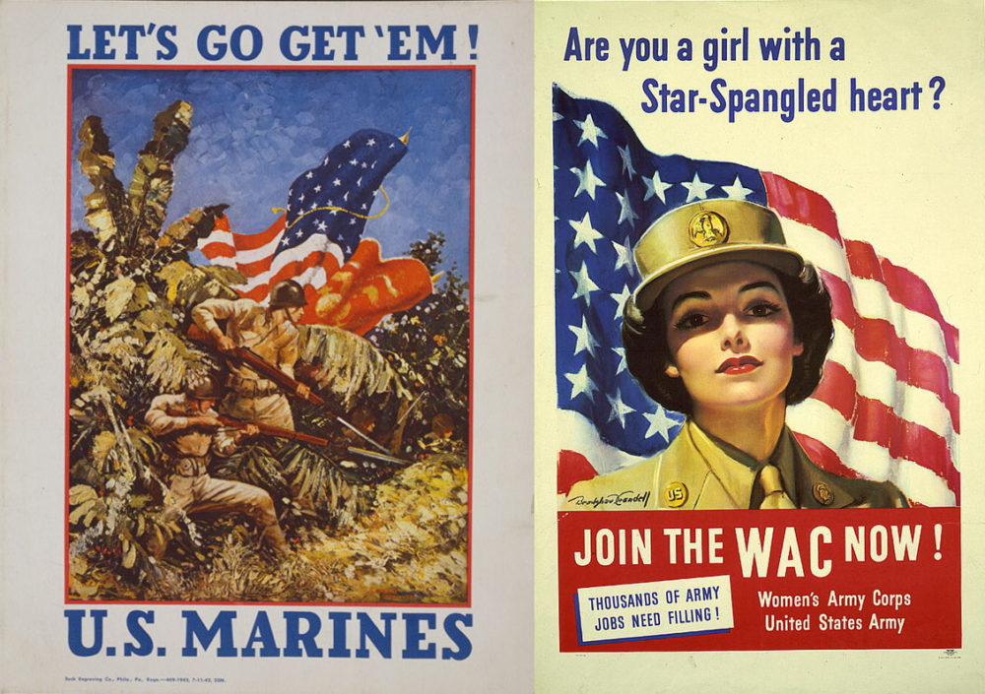
This pair of U.S. military recruiting posters demonstrates the way that two branches of the military—the Marines and the Women’s Army Corps—borrowed techniques from professional advertisers to “sell” a romantic vision of war to Americans. One shows Marines at war in a lush jungle, reminding viewers that the war was taking place in exotic lands; the other depicted women taking on new jobs as a patriotic duty.
Bradshaw Crandall, Are You a Girl with a Star-Spangled Heart? Recruiting Publicity Bureau, U.S. Women’s Army Corps Recruiting Poster (1943); Unknown, Let’s Go Get ’Em. Beck Engraving Co. (1942). Library of Congress. [Public domain via American Yawp]
Before you complete your discussion, make sure you refer to the course rubric for the expectations for this assignment. Participating in the course discussions is an important part of your final grade. In your discussions, you cannot simply reply to someone's posting with "ditto" or "I agree with you". You must answer the question(s) asked in a minimum of two paragraphs and a maximum of three paragraphs. Your responses should also quote and cite the material you have read in the class so far; you may also do outside research. Use the Purdue OWL Chicago Style guide for help with the correct citation style for your quotes.
Then, respond to at least TWO classmates’ postings referring to at least one element of critical thinking. Your response to your classmates should be a minimum of two sentences, and a maximum of four sentences (refer to your Introduction to Critical Thinking and to the How to Read History Sources modules for a review of how to read primary sources).

